SEO Metadata
- Focus Keyword: best brand design company in Kolkata
- Meta Title: Best Brand Design Company in Kolkata (2026 Guide) | Brewing Ideaz
- Meta Description: Looking for the best brand design company in Kolkata? Learn what to evaluate — portfolio, process, pricing & red flags — before you hire.
- URL Slug: /best-brand-design-company-in-kolkata

Secondary Keywords
- brand design company in Kolkata
- branding agency in Kolkata
- brand identity design Kolkata
- branding services in Kolkata
- creative design agency Kolkata
- logo design company Kolkata
- professional branding company Kolkata
- brand strategy agency Kolkata
- visual identity design Kolkata
- Brewing Ideaz Kolkata

Internal Linking Suggestions
Suggested Anchor Text | URL
Brand design services | /services/ or /brand-design/
Contact our team | /contact-us/
Explore our portfolio | /portfolio/ or /case-studies/

Best Brand Design Company in Kolkata: A Complete Guide to Choosing the Right Partner
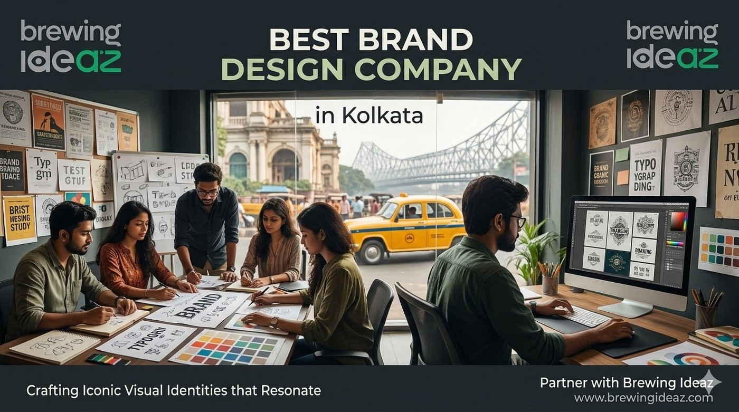
Kolkata has a rich creative heritage and a growing mix of traditional businesses modernising their image and new-age startups. With that growth has come many agencies claiming to be the “best brand design company in Kolkata.” For founders and marketing heads, the challenge is separating agencies that deliver strategic, scalable brand systems from those that only produce attractive logos.
This guide gives you a practical framework to evaluate brand design partners in Kolkata.

What “Best” Actually Means in Brand Design
Brand design is far more than a logo. A capable partner should help define positioning, tone of voice and audience, then translate that strategy into a complete visual identity system — logo, colour palette, typography, iconography and usage guidelines that work across website, packaging, social media, pitch decks and offline materials.
The right agency depends on fit. A studio strong in cultural or heritage brands may not be ideal for a SaaS or fintech startup, and vice versa.

Key Factors to Evaluate Before Hiring

Portfolio depth, not just polish
Ask to see full brand systems applied across multiple touchpoints, ideally with business impact.

Strategic process
Strong agencies begin with research and positioning before design.

Industry and cultural understanding
Kolkata’s market mixes traditional businesses, creative industries and emerging startups. Relevant experience matters.

Transparent pricing and timelines
Expect clear fee structures and realistic timelines (typically 3–8 weeks).

Ownership of files
Confirm you receive complete source files and full ownership.

Communication style
Check whether their working rhythm matches yours.

Why a Kolkata-Based Brand Design Agency Can Be an Advantage
Local agencies understand the city’s cultural nuances, business etiquette and audience mix. Overlapping time zones make collaboration smoother. Many Kolkata studios have experience helping both legacy businesses refresh their identity and new ventures build one from scratch.

Questions to Ask Before You Hire
- Can you walk me through your brand strategy process step by step?
- Do you have case studies in my industry or a similar stage of growth?
- What exactly is included in the final deliverable package?
- How many rounds of revisions are included?
- Who will be the primary designer and strategist on my project?

Red Flags to Watch For
Be cautious of agencies promising a complete brand identity in a few days, refusing client references, or offering prices that seem too good to be true without clear scope. Branding is a long-term asset; under-investing often leads to costly rework later.

Final Thoughts
The best brand design company in Kolkata for your business is the one that understands your audience, follows a clear strategic process, and delivers a system you can grow with — not just a logo file.

Ready to Discuss Your Brand?
Brewing Ideaz has a branch office in Kolkata (Bangur Avenue) and a corporate office in Bengaluru.
Call or WhatsApp: (+91) 62915 47048 Email: info@brewingideaz.com
We’re happy to share how we approach brand identity projects for growing businesses.

30 Frequently Asked Questions About Brand Design Company in Kolkata
- What is a brand design company? A brand design company helps businesses develop their brand identity, including logos, colours, typography, visual elements, and brand guidelines.
- How do I choose the best brand design company in Kolkata? Evaluate the company’s portfolio, strategic process, relevant industry experience, pricing, deliverables, and communication style.
- What services does a brand design company offer? Services may include brand strategy, logo design, visual identity, brand guidelines, packaging design, and marketing collateral.
- Why is brand identity important for a business? A consistent brand identity helps businesses communicate their values, establish recognition, and create a coherent experience across customer touchpoints.
- What is the difference between branding and brand design? Branding covers the broader process of shaping a brand’s identity and perception. Brand design focuses on the visual elements that express that identity.
- How much does brand design cost in Kolkata? Pricing varies depending on the scope, complexity, deliverables, and experience of the agency. Request a detailed quotation before hiring.
- How long does a complete brand identity project take? A full brand identity project may typically take 3–8 weeks, depending on the scope, feedback cycles, and project requirements.
- What should a brand design portfolio include? A portfolio should demonstrate complete identity systems, design applications, project objectives, and relevant examples of completed work.
- What is brand strategy? Brand strategy defines a brand’s positioning, target audience, values, messaging, and differentiation in the market.
- What is a visual identity system? A visual identity system includes the logo, colour palette, typography, imagery, and other visual elements used to represent a brand consistently.
- What is included in a brand identity package? Depending on the agreement, it may include logo variations, colour specifications, typography, brand guidelines, and digital or print-ready assets.
- Why should I check an agency’s industry experience? Relevant experience can help you assess whether the agency understands your audience, industry requirements, and business objectives.
- What questions should I ask before hiring a branding agency? Ask about the strategy process, relevant projects, deliverables, revision limits, project timeline, pricing, and team members.
- What are the red flags when hiring a brand design company? Unclear deliverables, unrealistic timelines, lack of relevant work, vague pricing, and unclear ownership terms deserve careful evaluation.
- What is the difference between a logo and a brand identity? A logo is one visual element of a brand. A brand identity is the broader system of visual elements and guidelines that represent the business.
- Do startups need professional brand design? Professional brand design can help startups communicate their positioning consistently and establish a recognizable identity as they grow.
- Can a brand design agency help with rebranding? Yes. Agencies may help businesses update their positioning, visual identity, messaging, and brand guidelines during a rebranding project.
- What are brand guidelines? Brand guidelines document how a brand’s visual and communication elements should be used consistently across different platforms.
- Why is brand consistency important? Consistent branding helps customers recognize a business and experience a coherent identity across its website, marketing materials, and other touchpoints.
- What file formats should I receive from a brand design company? Depending on the project, deliverables may include editable vector files such as AI or EPS, SVG assets, PNG files, and a brand guidelines PDF.
- Who owns the final brand design files? Ownership depends on the contract. Confirm the transfer of intellectual property rights, source files, and usage permissions in writing.
- How many revisions should a branding project include? Revision limits vary by agency and project. Confirm the number of included rounds and the cost of additional changes before signing.
- Why choose a Kolkata-based branding agency? A local agency may offer convenient communication, familiarity with the regional market, and opportunities for in-person collaboration.
- What is the difference between a branding agency and a marketing agency? A branding agency focuses on brand identity and positioning, while a marketing agency focuses on promoting products or services and reaching target audiences. Some agencies offer both.
- Can brand design improve customer trust? A clear and consistent brand identity can support credibility and recognition, although trust also depends on the actual customer experience and business practices.
- What is brand positioning? Brand positioning defines how a business wants its target audience to perceive it in relation to competing options.
- How can I compare two brand design companies? Compare their relevant portfolios, strategic approach, deliverables, project timelines, pricing, communication, and contractual terms.
- What is the role of typography in brand design? Typography influences the visual character, readability, and consistency of a brand’s communication.
- Does a brand design company provide ongoing support? Some agencies offer ongoing design support or brand management services. Confirm availability, scope, and pricing directly with the agency.
- How can I contact Brewing Ideaz for brand design services in Kolkata? You can contact Brewing Ideaz by calling or WhatsApping +91 62915 47048 or emailing info@brewingideaz.com to discuss your branding requirements.

